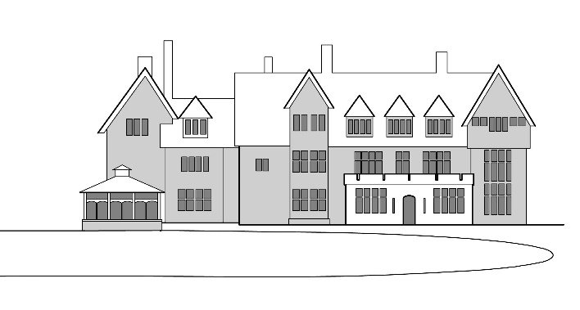
Christian Conference Centre
Leiston
Suffolk
IP16 4TX
Tel: 01728 830715
e: office@sizewellhall.org.uk www.sizewellhall.org.uk
Registered Charity no. 269157
An engaging environment that promotes Christian values, Faith & Community

Resident Managers:- Clive & Kathie Cornelius, Rob & Lesley Aldred.

Christmas Crafts, Cake & Canapes
Tuesday 1st to Thursday 3th December 2020 BOOKING FORM

I would love to come on 2020s Christmas Crafts please register me!
☐ Mr & Mrs ☐ Mr ☐ Mrs ☐ Miss
(PLEASE PRINT)
Surname: First Name:
Address:
Email:
Post code: Telephone:
Any Special Dietary Requirement:

We at Sizewell Hall Ltd do not pass on or sell your data to any third parties. We promise to keep your data safe and secure. We will only use this information to contact you about your booking. If you change your mind at a later date, all you have to do is call us on 01728 830715 or email office@sizewellhall.org.uk to have your details removed. For more information, please go to sizewellhall.org.uk/privacy policy.
☐ Please tick I am happy for you to keep in touch with me with regards to my booking.
Cost per person for 2020 - £145
I enclose a non-returnable deposit of £ (£30 per person)
Please make cheques payable to: Sizewell Special Projects
Or Bank Transfer payment to:
A/C no: 63929345 sort code: 20-98-07
I have paid by cheque ☐ BACS transfer ☐ Signed:

I am happy to share a room with

Please return completed form to:
Any questions?
Email: bookings@sizewellhall.org.uk
Or ring 01728 830715

Christmas Crafts Admin
Sizewell Hall
Leiston
Suffolk
IP16 4TX

