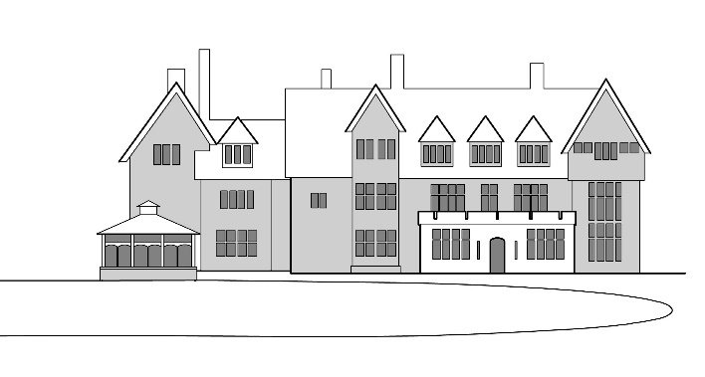
Christian Conference Centre
Leiston
Suffolk
IP16 4TX
Tel: 01728 830715
e: office@sizewellhall.org.uk www.sizewellhall.org.uk
Registered Charity no. 269157
An engaging environment that promotes Christian values, Faith & Community

Resident Managers:- Clive & Kathie Cornelius, Rob & Lesley Aldred.

SIZEWELL HALL BIRD WATCHING BREAK 2020
Tuesday 9th to Friday 12th June 2020, BOOKING FORM

I would love to come on 2020’s Bird Watching Break please register me!

(PLEASE PRINT)
□ Mr & Mrs □ Mr □ Mrs □Miss

Surname:
First Name:
Address:
Postcode:
Email:
Telephone: Mobile:
Any Special Dietary Requirement:

Cost per person for 2020 - £145.
I enclose a non-returnable deposit of £ (£30.00 per person)
Please make cheques payable to: Sizewell Special Projects
Or Bank Transfer payment to:
a/c no: 63929345 sort code: 20-98-07
I have paid by ◻ cheque ◻ BACS transfer Signed:

I am happy to share a room with

Please return completed form to:
Any questions?
Email: bookings@sizewellhall.org.uk
Or ring 01728 830715

Bird Watching Break Admin
Sizewell Hall
Leiston
Suffolk
IP16 4TX

