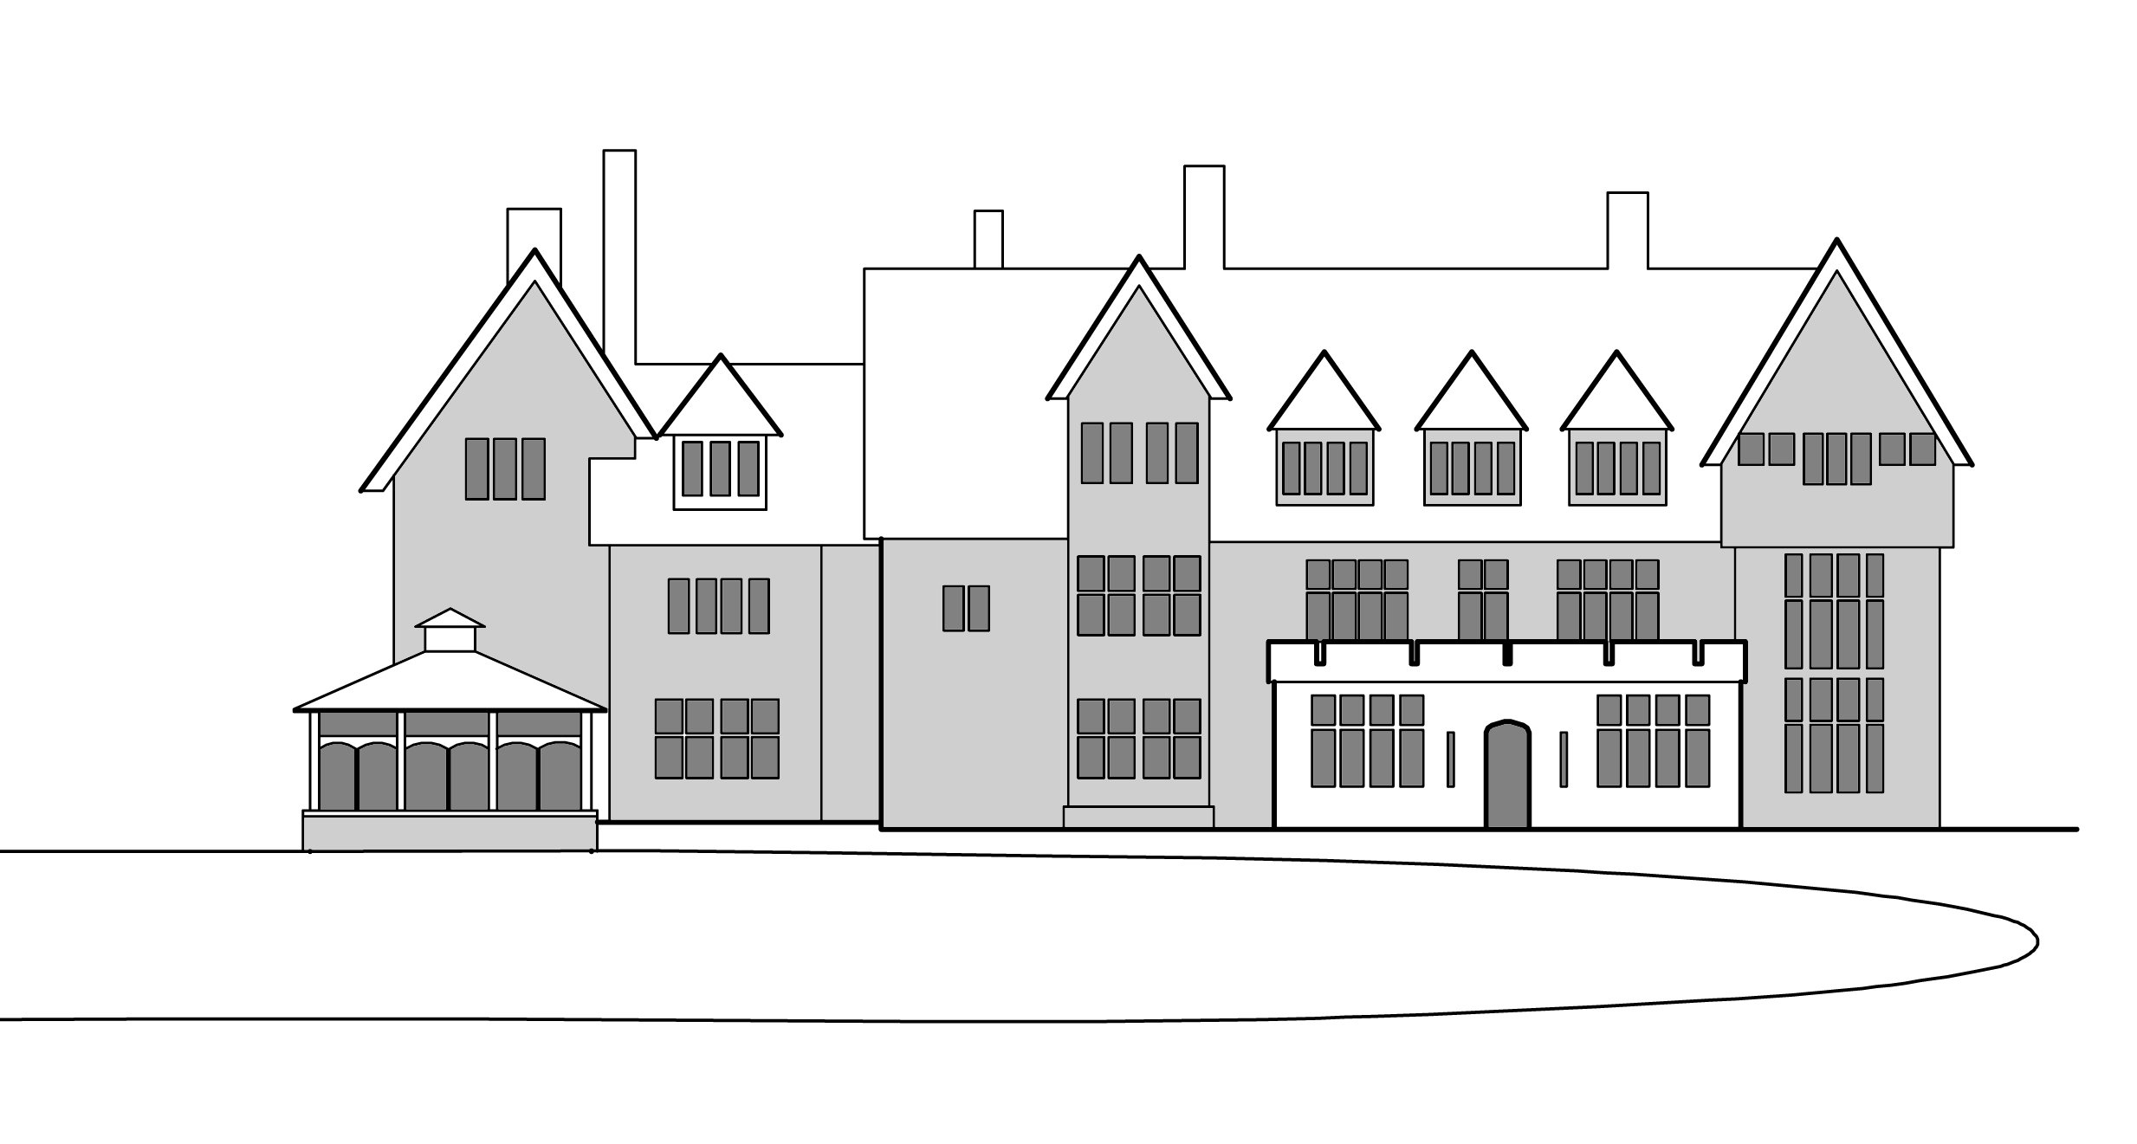
Sizewell Hall
Christian Conference Centre Registered Charity no. 269157
Leiston Suffolk IP16 4TX. Tel: 01728 830715
e: office@sizewellhall.org.uk www.sizewellhall.org.uk

Chairman :- Colin Low.

CONFERENCE HALL & CAMPSITE CHARGES 2021

Version 2

Sizewell Hall 2021 prices (per person)
 | Weekend | Mid Week | Full Week (any time)
 | 2 Night stay | 4 Night stay | 7 Night stay
 | Arrival - 4pm | Arrival - 4pm | Arrival - 4pm
 | Depart – 5.00pm | Depart – 10.30am | Depart – 10.30am
Hall:
Adults (5yrs of age & over) | £49 per head | £81 per head | £112 per head
Additional guests (over 70 in number) | £46 per head | £77 per head | £109 per head
0 to 4yrs of age | £5 per head | £5 per head | £6 per head
Minimum Charge (Not applying due to COVID-19) | £2,900 | £4,900 | £6,700
Day Visitors (Adults and children 5 years & over): | £12 per day | £12 per day | £12 per day
Campsite:
 | Weekend | Mid Week | Full Week (any time)
Adults (5yrs of age & over) | £27 per head | £37 per head | £42 per head
0 to 4yrs of age | £5 per head | £5 per head | £6 per head
Minimum Charge (Not applying due to COVID-19) | £540 + Electricity | £740 + Electricity | £840 + Electricity
Day Visitors (Adults and children 5 years & over): | £12 per day | £12 per day | £12 per day
Forge Cottage & The Bungalow
Forge Cottage | Weekend | Mid Week | Full Week (any time)
Groups (70 and less adults) | £185 | £240 | £290
Guest | £325 | £415 | £500
The Bungalow | Weekend | Mid Week | Full Week (any time)
Groups (70 and less adults) | £135 | £185 | £240
Guest | £250 | £315 | £375

