**Attendance is not restricted   
To attend this weekend you do not have to attend church regularly, even attend church at all, or be   
attached to any church denomination.**

**Sizewell Weekend**

**Friday 9th May – Sunday 11th May**

**2025.**

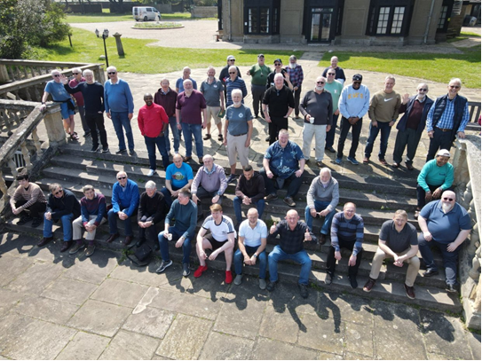

**Attendance at all sessions is optional.**

**All bed linen is provided.**

**Please bring your own towels.**

**There will be a Rota to help with serving and helping with the washing up and dishwasher.**

**If you are a musician, please let us know and we can involve you in the worship if you would like.**

**Further information and booking forms from:   
Rachael Wallace**

**44 Oakey Field Road**

**Thurston**

**Christian Viewpoint**

**For Men**

**Bury St Edmunds**

**Suffolk**

**IP31 3RX**

**Phone: 01359 231084**

[**Email: menssizewellweekend@gmail.com**](mailto:menssizewellweekend@gmail.com)

|  |
| --- |
| **Sizewell has a lift to all floors**  **to assist those not able to climb the stairs.** |

**Leaders: Phil Sparkes, Victor Jack Tony Hood and Mark Wallace**

**General**

**.**

**Sizewell Hall stands right on the sea front and is an ideal place for being with friends. This is a special weekend catering for men designed to encourage one another in the Christian faith. There will be ample time for relaxation which includes snooker, table tennis, darts, walking, tennis, squash, and other indoor games. There are some organized activities and some free time.**

**Please let us know, via the booking form, if you are willing to share a room with friends, there are however only a few single rooms available. Bookings will be accepted on a 'first come, first served' basis for single rooms.**

**This weekend is open to ALL MEN over the age of 18 from any background.**

**Arrival and Departure**

**Please plan to arrive between 5.00 and 7.00pm on Friday 9th May 2024.**

**The Evening meal will be at 7.30pm.**

**Departure will be between 3.00 - 4.00pm on Sunday 11th May 2025.**

**Cost.**

**The cost will be £102.00 per person of which £32.00 must be sent as a Non-Refundable/Transferable Deposit when booking.**

**The remaining amount (£70.00) is to be paid by 31st March 2025. If you wish to pay in full, £70 will be refundable if you need to cancel. *(Cheques made payable to C.V.M.)***

**Final Instructions**

**You will receive your final instructions with a kit list and a programme at the end of March 2025. This will be by email if you supply your email on your application form.**

|  |
| --- |
| **Speaker: Steve Fenning** |
|
|  |

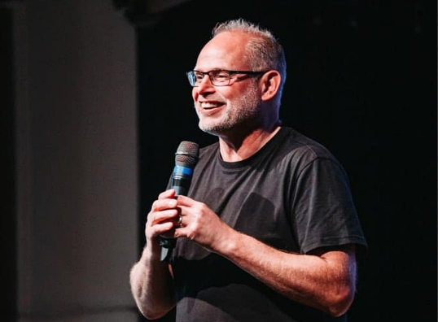

**It was only a few months after Bobby Moore held the World Cup aloft at Wembley that Steve Fenning was introduced to the world! Being born a farmer’s son, everything pointed to him joining the generations of Fennings before him in working the land… but life took a different turn at 19 years of age when he quit agricultural college (after one whole term!) and joined The Saltmine Trust for three years, gaining experience in schools work and evangelism around the UK. At 21, he returned to Suffolk to work part-time with his Church at Brockford and part time as an evangelist. Steve (and his first wife, Sara) initiated the start of a new Church in Mendlesham in 1992 and 31 years on, he is still leading this church which now meets in Debenham and is known as ‘The Forge’.**

**Steve is the proud dad of three children - Sam, Alice and Rachel and following Sara’s death in 1999, he has been happily married to Sarah for 22 years. He’s also a very youthful grandad to 2 granddaughters!**

**He is a sports fan and an optimist, supporting Ipswich Town and passionately following English Cricket! He dreams of one day having a golf handicap below 18 (sadly it’s just a dream)**