LEADERS  TONY HOOD, PHIL SPARKES, MARK WALLACE AND JOE KIRK.  FURTHER INFORMATION  AND BOOKINGS FORMS FROM:  RACHAEL WALLACE  44 OAKEY FIELD ROAD  THURSTON  BURY ST EDMUNDS  SUFFOLK.  IP31 3RX  01359 231084  Email:  menssizewellweekend@gmail.com |  |  |  | Extra Information:  All bed linen is provided  Please bring your own towels  There will be a rota to help with serving food and making drinks.  If you are a musician, please let us know and we can involve you in the worship.  The shop will be open Friday evening and several times on Saturday.  Sizewell has a lift to all floors to assist those not able to climb the stairs.  Attendance at all session is optional.  Please bring along any board games that groups could play.  We will be having a bonfire on the beach. | CHRISTIAN  VIEWPOINT  FOR MEN  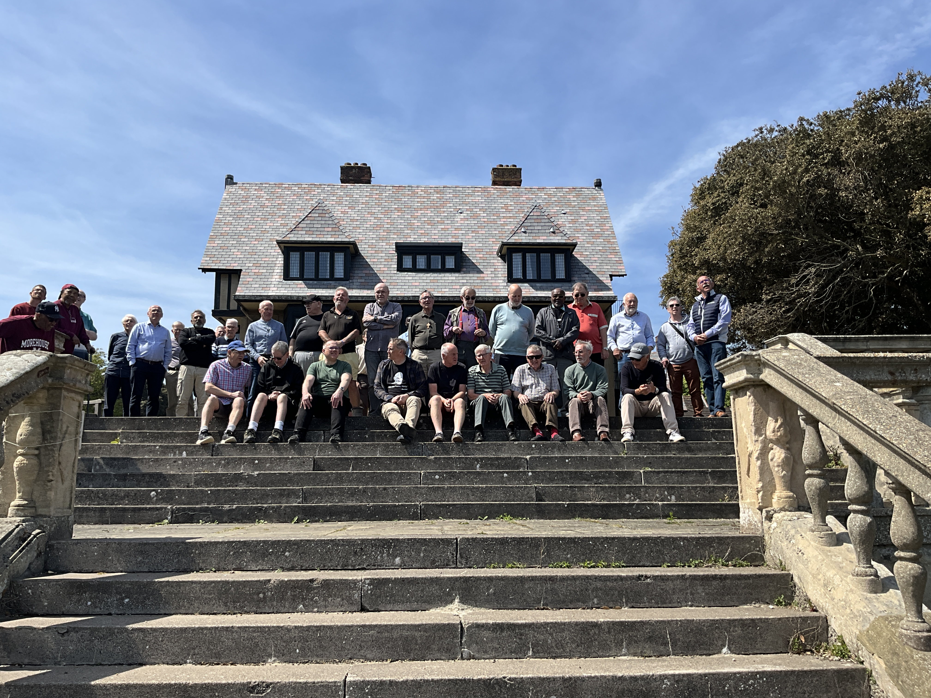  SIZEWELL  WEEKEND  8TH – 10TH MAY  2026

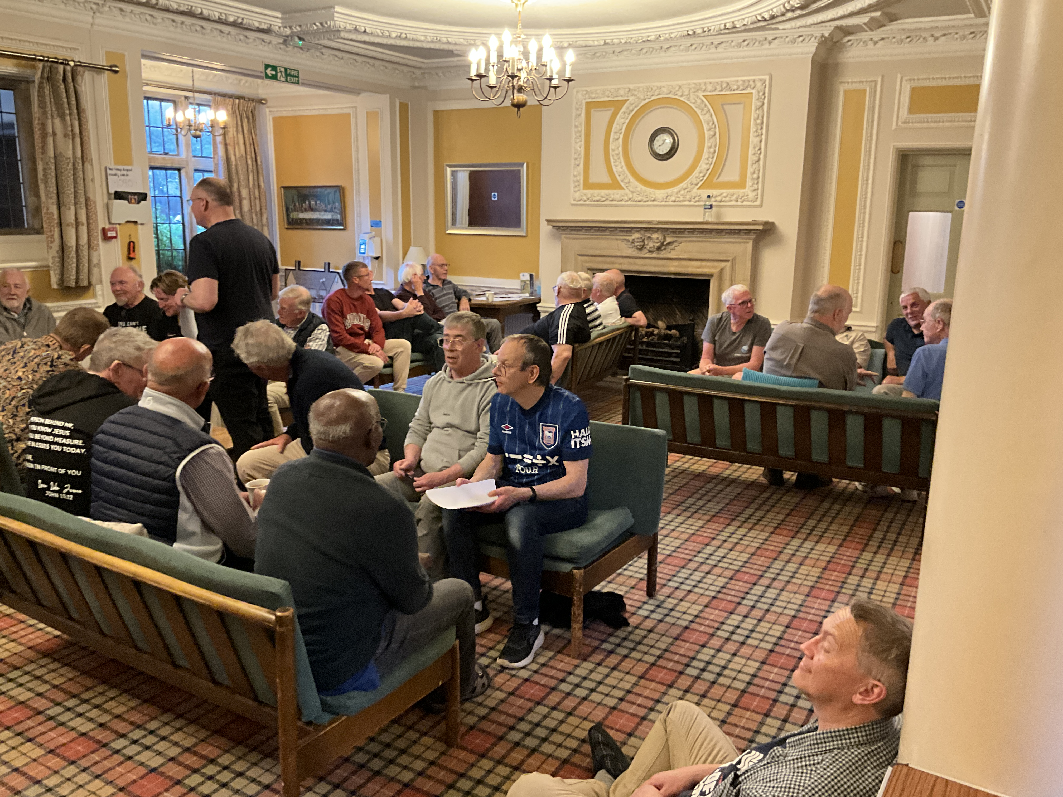  GENERAL  Sizewell Hall stands right on the sea front. This is a special weekend designed for men to encourage one another in the Christian faith.  There is ample time for relaxation which includes snooker, table tennis, darts, walking, tennis and other indoor games. There will be some organised activities and some free time.  Please let us know on the application form if you are willing to share a room. There are a few single rooms, but bookings for a single room will be on a “first come first served” basis.  This weekend is open to all men over the age of 18 from any background and you do not have to attend church to attend the weekend. | Arrival and departure:  Please plan to arrive between 5.00pm and 7.00pm on Friday 8th May 2026.  The evening meal will be at 7.30pm.  Departure will be between 3pm and 4pm on Sunday 10th May 2026.  Cost  The cost will be £107 per person of which £32.00 must be sent as a non-refundable deposit when booking. The remaining amount £75.00 is to be paid by 31st March 2026. If you wish to pay in full, £75 will be refundable if you need to cancel. (cheques made payable to CVM)  Special offer: If you bring someone along for the 1st time or someone who hasn’t been for at least a couple of years then you will both be able to come for last year’s price of £102 each. Or if a father and son come together, they too will come for last year’s price of £102.  Final Instructions  You will receive your final instructions with a kit list and a programme at the end of March 2026. This will be by email if you supply your email on your application form. | Our speaker this year is Steve Fennning.  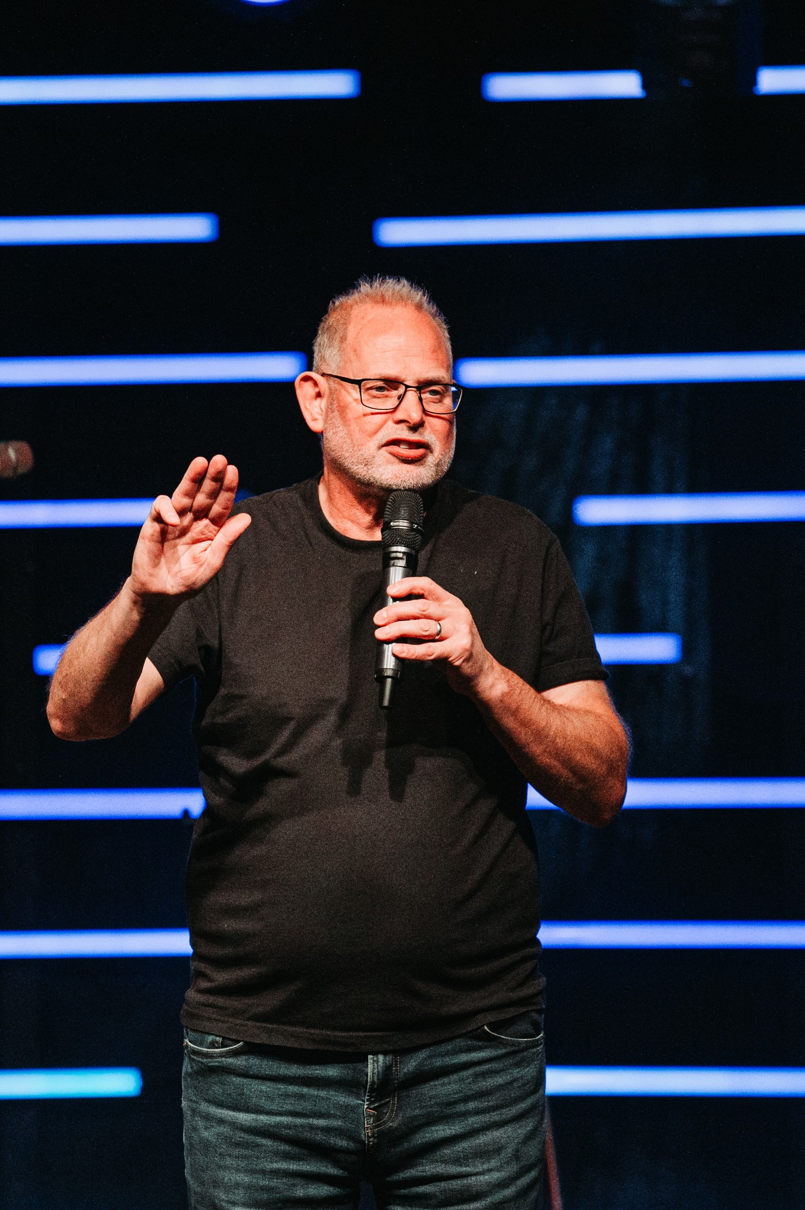  Steve was born into a farming family in Suffolk. He started to work part time with his Church at Brockford as an evangelist. After a while, Steve and his first wife Sara initiated the start of a new church in Mendlesham. Over 30 years on Steve is still leading that church called “The Forge” based in Debenham. Steve has three children Sam, Alice and Rachel and following Sara’s death in 1999, he has been happily married to Sarah for over 20 years. He is also a very proud (youthful) grandad to 2 granddaughters. He is a sports fan supporting Ipswich Town and passionately following English cricket. He also loves golf and dreams of having a golf handicap below 18!

